Banner 8

Human Resources EPAF

Hire Part Time EHRA Staff

E50PTS

UNC Charlotte Financial Services

Instructions on the topics below can be found in the [EPAF General Instructions](http://finance.uncc.edu/sites/finance.uncc.edu/files/media/Banner/TrainingDoc/EPAF_General_Instructions.docx) documentation.

* Logging into the EPAF system
* Originating EPAFs
* Approving EPAFs
* Designating a Proxy Approver
* Acting as a Proxy
* Setting up a Default Routing Queue

Steps to Create an EPAF

The following pages describe the nine steps required to originate and submit an EPAF for a Part Time EHRA Staff:

Step 1: New EPAF Person Selection

Step 2: New EPAF Job Selection

Step 3: New Employee Information

Step 4: Creating Assignment

Step 5: Enter Assignment

Step 6: Labor Distribution / FOAP

Step 7: Approval Routing Queue

Step 8: Comments

Step 9: Save & Submit

Steps 1 and 2 are the foundations of the EPAF. All of the other steps can be modified during the EPAF creation process or after an EPAF has been returned for correction – except Steps 1 and 2. So, it’s important to be accurate.

**Step 1 - New EPAF Person Selection**

**\*\*\*The deadline for submitting an EPAF to be paid on the 15th Payroll is the 1st day of the month. \*\*\***

**\*\*\* The deadline for submitting an EPAF to be paid on the End of Month Payroll is the 15th of the month. \*\*\***

*** Before beginning a new EPAF, please follow guidelines for setting up the defaults for Routing Queues in the EPAF General Instructions documentation. ***

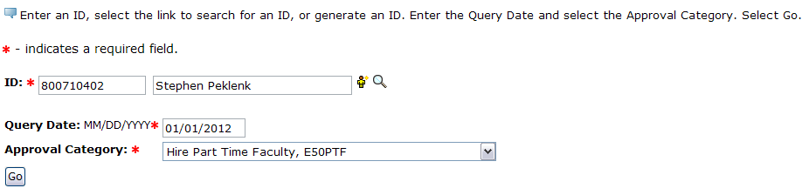

* Begin by searching for the employee for whom the EPAF is being created. If the person is already an employee of the University, simply type their UNC Charlotte ID # into the ID field. If it is not known if the person is an employee, then search the employee data base. If the person is not an employee, please contact Academic Affairs so that a UNC Charlotte ID # can be created.
* Enter Query Date – The first day of the first pay period the part time employee is paid.
  + Pay date = 15th of month – Query date = 1st day of month
  + Pay date = last day of month – Query date = 16th of month
* Choose Approval category – **Hire Part-Time EHRA Staff, E50PTS**
* Click the **GO** button.

**Step 2 - New EPAF Job Selection**

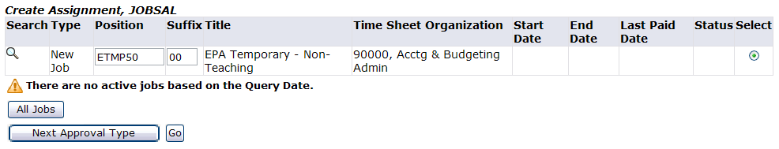

* **Position**: Enter **ETMP50** in the position number field and tab to Suffix field. It is very important to use tab.
* **Suffix:** Enter the two digit suffix and tab. Note: If nothing appears in the Time Sheet Organization field after hitting tab stop and re-start the EPAF.
  + To determine the suffix, click the **All Jobs** button at the bottom of the page.
    - If the employee has no assignments the suffix should be 00.
    - If the employee is being appointed to a new position number the suffix should be 00.
    - If the employee has a job listed with the same position number as the one being assigned the suffix should be 01, 02, etc. Add one to the previous suffix.
* Click the button.
* If an EPAF has already been created for this person that is still in the approval process, the following message will appear. ****A new EPAF cannot be created until the first one has been posted to Banner.

**Step 3 - Employee Information**

The **Employee Information** section sets the person up as an employee in Banner HR.

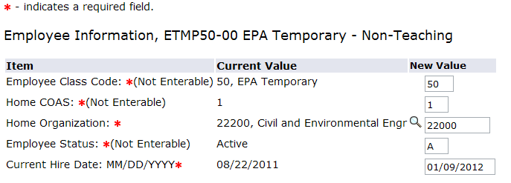

* **Employee Class Code –**defaults to 50 (EHRA Temporary) – cannot be changed
* **Home COAS –** defaults to 1 (University) – cannot be changed
* **Home Organization –** enter the orgn that the part time EHRA staff will work for or press the  to search for an orgn
* **Employee Status –** defaults to A (Active) – cannot be changed
* **Current Hire Date: MM/DD/YYYY -** enter the Part Time EHRA Staff’s Beginning Contract date.

**Step 4 - Creating Assignment**



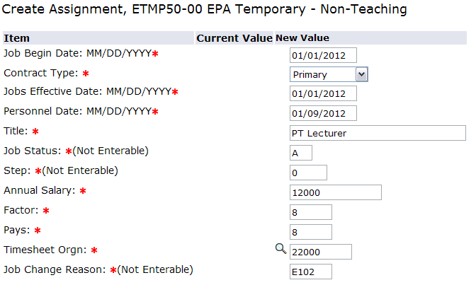

* **Job Begin Date** - The first day of the first pay period the part time EHRA staff is paid (same as the Query Date).
  + Pay date = 15th of month – Job Begin Date = 1st day of month
  + Pay date = last day of month – Job Begin Date = 16th of month
* **Contract Type**
  + **Primary** – first assignment for this employee
  + **Secondary** – use if this is not the employee’s first assignment
  + **Override** – do not use
* **Jobs Effective Date**  - same as Job Begin Date and Query Date
* **Personnel Date** – date employee begins work
* **Title** – title of position
* **Job Status** – Active (not overrideable)
* **Step** – 0 (not overrideable)
* **Annual Salary** – enter the amount the employee will be paid for this time period
* **Factor** – The number of pays per assignment period. This is always the same as the Pays.
* **Pays** – The number of pays per assignment period. This is always the same as the Factor.
* **Timesheet Orgn** – enter the orgn that the part time EHRA staff will work for or press the  to search for an orgn
* **Job Change Reason** – E102 defaults in (not overrideable).

**Step 5 - Ending the Assignment**



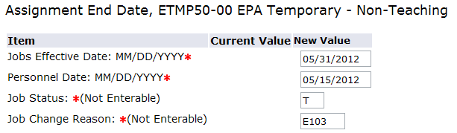

* **Jobs Effective Date**  - Last day of the pay period the employee works
  + Pay Period = 1st thru 15th – Jobs Effective Date = 15th of month
  + Pay Period = 16st thru last day of month – Jobs Effective Date = last day of month (always the last day of the month even if this is a weekend or holiday)
* **Personnel Date** – employee’s last day of work
* **Job Status** – T (not overrideable)
* **Job Change Reason** – E103 (not overrideable)

Change to first day of pay period

**Step 6 – Labor Distribution/FOAP**

* This step determines how the labor for this position will be charged within Banner Finance. The **FOAP** is a four-part numeric sequence that includes a **Fund**, **Organization**, **Account**, and **Program** number. The **Index** should always be used to populate the correct FOAP information.
* Enter only the **Index** of the Fund the assignment will be paid from and press. An error message will appear stating that the Account Code is required.

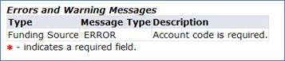

* Return to the **Funding Source** section and enter the **Account**. For part time EHRA staff use 911200 – EHRA Temp Staff. Press .

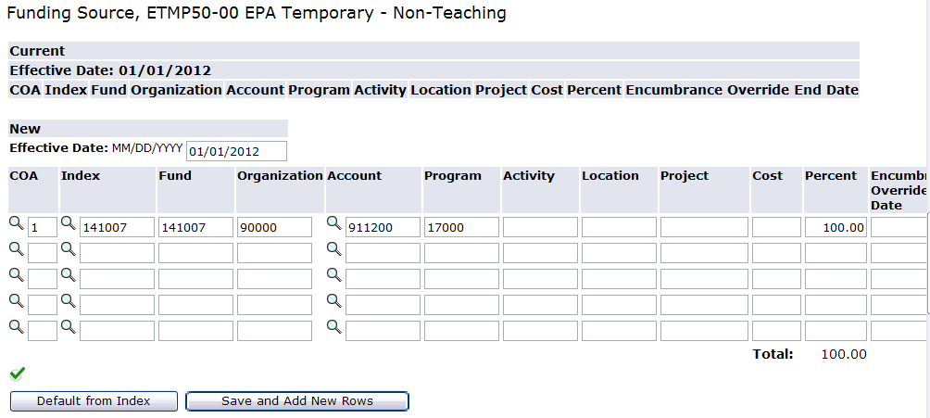

**Split Funding an Assignment**

* To split fund an assignment enter the **Index** for the **first** fund. Tab to the **Percent** and enter the percentage to be paid from this fund and press.
* An error message will appear stating that the Account Code is required.



* Return to the **Funding Source** section and enter the **Account**. For part time EHRA staff it will always be 911200. Press.
* Tab to the second **Funding Source** line and enter the **Index** for the **second** fund. Tab to the **Percent** and enter the percentage to be paid from this fund and press Tab to the **Percent** and enter the percentage to be paid from this fund and press.
* An error message will appear stating that the Account Code is required.



* Return to the **Funding Source** section and enter the **Account**. For part time EHRA staff it will always be 911200. Press.
* The Total must be 100%.
* The **Encumbrance Override End Date** column will not be used at this time.

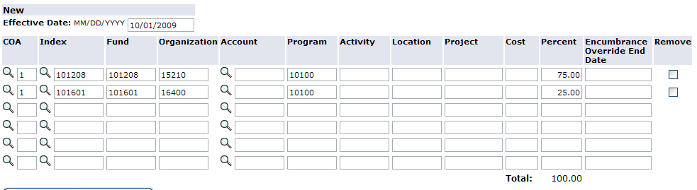

**Step 7 - Creating the Routing Queue**

* Required Approval Levels have been set up for each EPAF. Click the  to select an approver. When all approvers are selected, press .
* Before an EPAF is created for the first time, default User Names can be added for the Approval Levels. The instructions for creating the defaults can be found in the EPAF General Instructions referenced on Page 1.
* (FUND) Fund Approval
  + Grants (5XXXXX) – Lou Harrell
  + Auxiliary Funds (3XXXXX) - Hong Vu
  + All other Funds – Account Code 911200 (Non-Teaching): Sarah Ekis

* There are three possible Required Actions:
  + **Approve** - The individual is required to “approve” the EPAF. The EPAF cannot be approved at a higher level until is it is approved at lower levels.
  + **Apply** - Only an individual at the HR level can “apply” an EPAF. This is the action that occurs when an EPAF turns into a jobs record in the payroll system.
  + **FYI** - An EPAF originator can select additional individuals at different levels to “FYI” or “acknowledge” the EPAF. Unlike the required action to “approve,” an EPAF can be approved and applied at higher levels if the EPAF Approver doesn’t perform the required action of “FYI.”

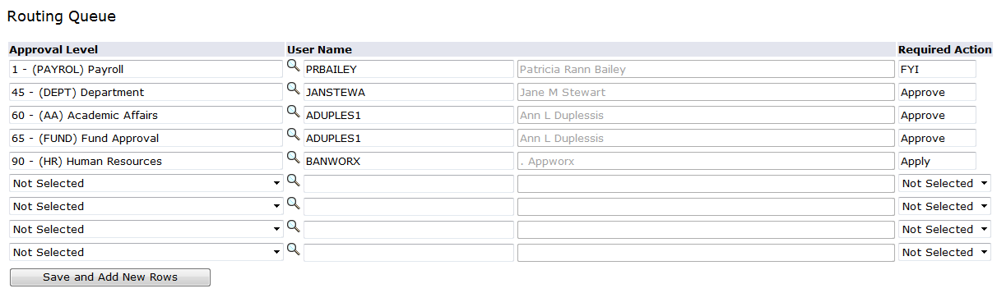

**Step 8 - Adding Comments**

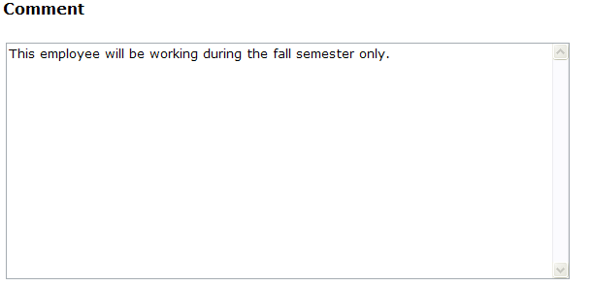

* A description or reason must be entered into the comments section of the EPAF by the originating department.
* A proxies name will not appear in an EPAF as the Originator. Use the Comment section to show the proxy that approved the request.
* Once comments are “saved,” they cannot be changed. Be careful with articulating comments. An EPAF user can make multiple comments to the EPAF and comments can be attached to the EPAF at any approval level.

**Step 9 – Save & Submit**

* To complete the EPAF, click **Save** then **Submit**. If there are any data validity issues within the EPAF, Banner will display two types of messages:
  + **ERROR** - Error messages will not allow the EPAF to progress to the approval levels. Errors must be corrected. Read the details provided, and correct the errors as indicated.
  + **WARNING** - Warning messages simply deliver information, and allow the EPAF to progress successfully. Usually, warning messages inform the originator, approvers, and payroll department about budget issues associated with the job.
* The originator must log into the EPAF Originator Summary to view, void, update, or re-submit the EPAF.