EPAF General Instructions

UNC Charlotte Financial Services

INDEX

- OVERVIEW & LOGGING IN …....……………….PG 3
- EPAF Originator Summary ………………………...PG 5
- Approving EPAFS………….……………………….PG 8
- Designate a Proxy Approver………………………...PG 11
- Act as a Proxy Approver ……………………………PG 12
- Set up a Default Routing Queue ……………………PG 13

OVERVIEW: EPAF Defined

An Electronic Personnel Action Form - EPAF, is an online form originated by a department to communicate an employment decision about an employee to the Human Resources and Payroll Department.

All EPAFs require approval. Each EPAF is assigned an “Approval Category” that determines the required levels of approval. Finally, the EPAF is approved by the Human Resources Department, and the EPAF is applied to the employee’s job record. If there are any problems with the EPAF, a designated Approver can select Return for Correction and require the originator to correct or recreate the EPAF.

The EPAF must be completed, approved, and applied in a timely manner so the employees’ job record can be updated. Timely completion of an EPAF is essential to help the Payroll Department pay an employee accurately and on time. A complete EPAF Submission Schedule can be found on the Payroll Calendar.

Currently UNC Charlotte uses the following EPAFS:

• Hire Part Time Faculty – E50PTF
• Hire Continuing Ed Part Time Employee – E50CE
• Special Pay for Full Time Employee – E45SP
• Student New Hire – S70N
• Student Reappointment – S70R
• Student Miscellaneous Pay – S72M

I – Logging In

- Log in to https://my.uncc.edu/ using a NinerNET ID and password.
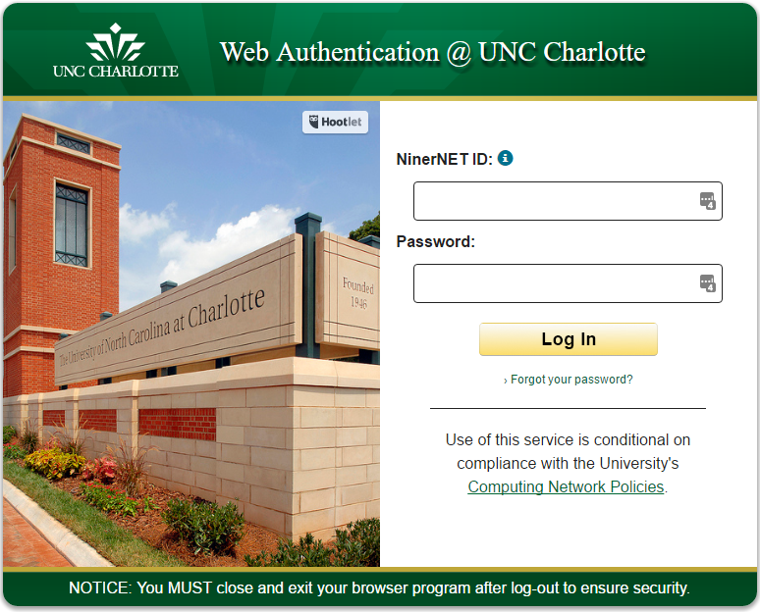
Select Banner Self Service under the Essentials section.

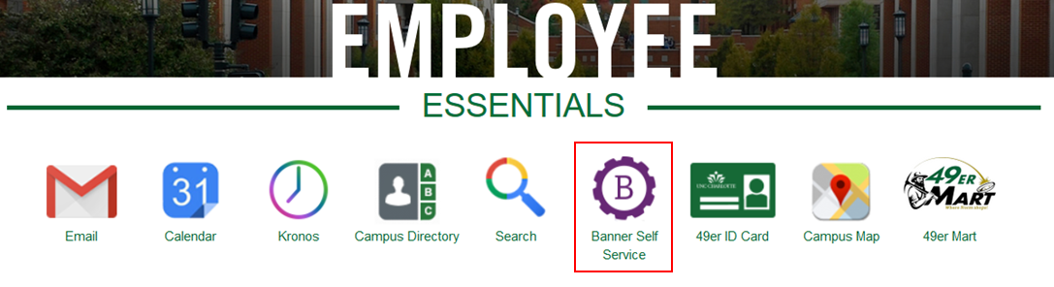

Click on the Employee tab and then on EPAF – Electronic Personnel Action Form link.

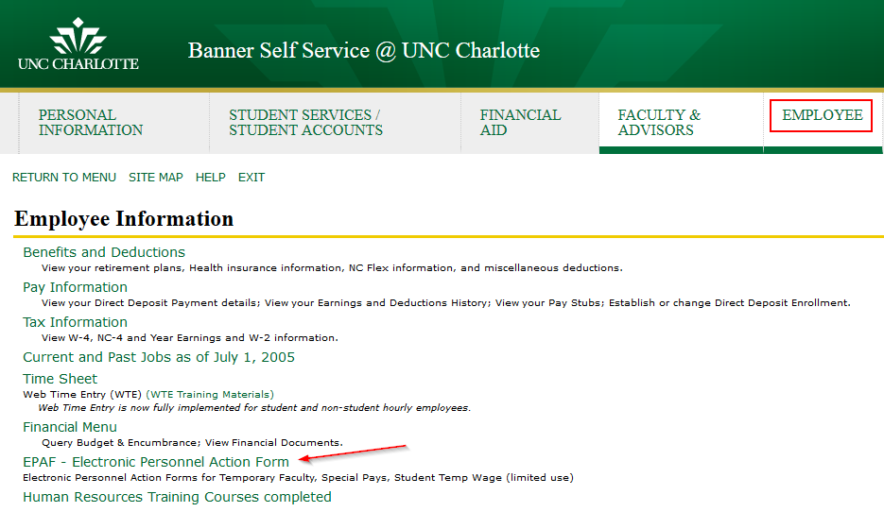

II - EPAF Originator Summary

The EPAF Originator Summary stores EPAFs that the Originator has created, voided, saved, or submitted. It also contains EPAFs that have been Returned for Correction and require the Originator’s attention.

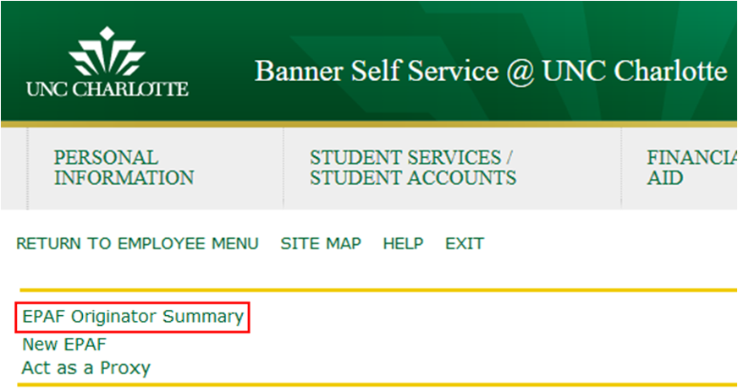

Within the EPAF Originator Summary, there are two tabs: Current and History.

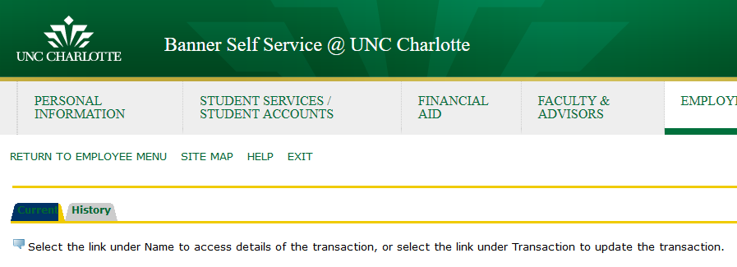

Current Tab

The Current tab is similar to an “inbox” for the EPAF Originator Summary. Two types of EPAFs appear in the Current tab:

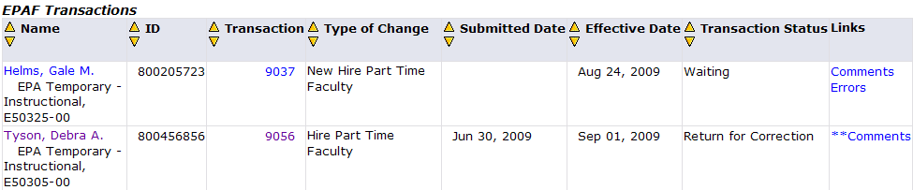

- Waiting - If an EPAF has been created and saved (but not submitted), it remains with the Waiting status and can be found in the EPAF Originator Summary.
- Returned for Correction - If an EPAF contains an error or incorrect data, instead of approving it, an Approver will return it for correction. To view a returned EPAF, click on the employee’s name.

Usually, the Approver will note the reason for the return under the Comments of the EPAF. The EPAF Originator has two options: Void or Update.

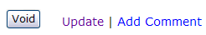

- Clicking Void will permanently inactivate the EPAF.
- Click Update to make any changes to the EPAF.
- Only the Originator can make changes to the EPAF. If the Originator makes changes, they must save and submit the EPAF to send it through the Approval Queue. The EPAF must be re-approved on all levels.

History Tab

All EPAFs created by the Originator are stored in the History tab. To check the status of an EPAF, in the EPAF Originator Summary, click the History tab, and notice the Transaction Status of the EPAF.

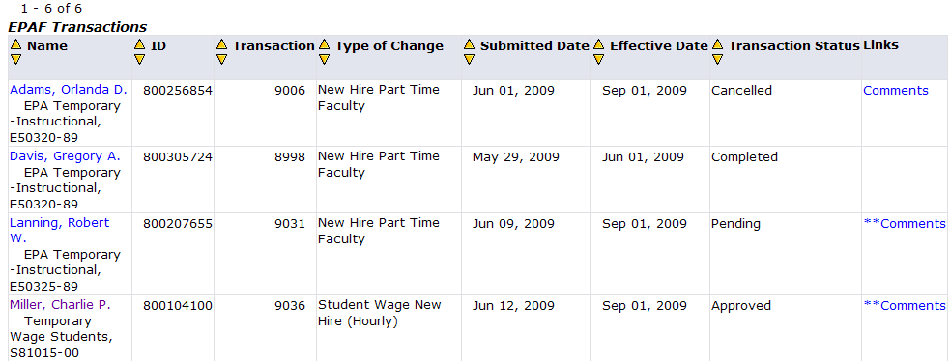

Possible transaction statuses include:
- Pending - The EPAF is pending approval.
- Complete - The EPAF has been completed and applied to the employee’s job file.
- Returned - The EPAF has been returned for correction.
- Voided - The EPAF has been voided but its history remains available.
- Overridden - The EPAF has been overridden and approved by a Super User at the Payroll level.
- Removed from Queue - The EPAF has been returned to the Originator for correction thus is removed from the Approval Queue.

The Originator can only modify an EPAF if it has not been viewed or approved at a higher level in the approval queue. Click on the EPAF, and if the option Return for Correction exists, then the Originator may return it to him or herself, make a change, then resubmit.

III – Approving EPAFS

The EPAF Approver Summary contains EPAFs that have the Approver listed in the Approval Queue. To access the EPAF Originator Summary.

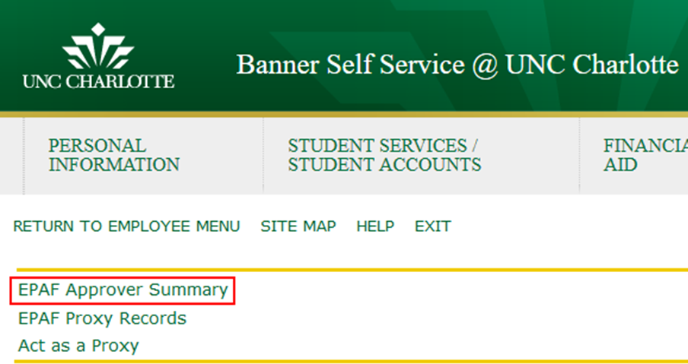

Within the EPAF Originator Summary, there are three tabs: Current, In My Queue, and History.

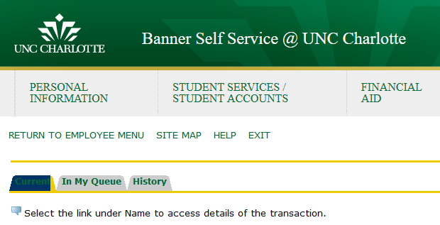

Current Tab

The Current tab is similar to an “inbox” for the EPAF Approver Summary. EPAFs that require the Approver’s attention appear here.

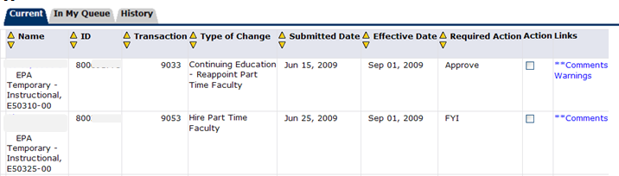

- An EPAF can be approved by two ways.
  - Check the “Action” box next to each EPAF to be approved. Click Save.
- To view an EPAF, click on the employee’s name. Review the EPAF. The Approver then has two options:
  - Approve - Click Approve to approve the EPAF. Approving an EPAF confirms the information is correct and authorized. The EPAF immediately becomes available for approval at the next level.
  - Return for Correction - Click this button to return the EPAF to the Originator for correction. The originator may correct and resubmit the EPAF or it can be voided.

- Approvers who return EPAFs must add a Comment to the EPAF indicating the reason for return.
- An Approver can Add Comments to the EPAF regardless of the required action or transaction status.

- If the Required Action of an EPAF is Acknowledge or FYI, the Approver only has one option. However, the Approver can add a comment to the EPAF.
- To approve a group of EPAFs click the box under Action or press in the Current tab. After selecting the EPAFs to receive the Required Action, click Save.

In My Queue Tab

The In My Queue tab shows EPAFs that are pending in the queue of the Approver. However, these EPAFs may not have been approved yet at a lower level. Or the EPAFs may be ‘voided.’

History Tab

The History tab shows EPAFs that have been approved or acknowledged by the Approver.

Search

Click on Search to find EPAFs by UNC Charlotte ID #, Employee Name, EPAF Transaction Number, and more. The search function will search the Current, In My Queue, and History tabs.

Proxy or Superuser or Filter Transactions

Click on Proxy or Superuser or Filter Transactions to find EPAFs for a certain date range or to act as a proxy.

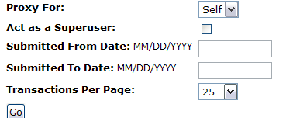

- To act as a Proxy, select the approvers name form the Proxy For: dropdown and press Go. Please note – a person cannot act as a proxy until they have been added by another approver.

- To search for an EPAF by date range, enter the beginning and end date and press Go.

IV - Designate a Proxy Approver

To designate a proxy, select EPAF Proxy Records.

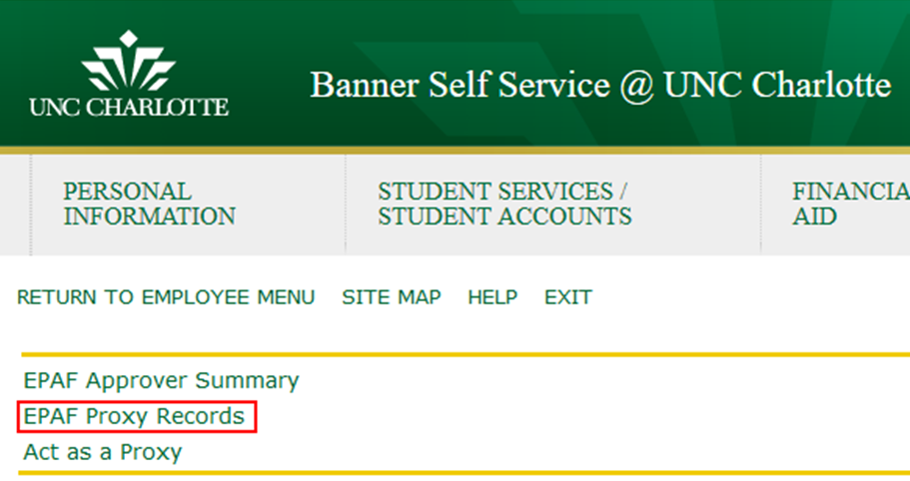

Select the Approval Level for which you wish to designate a Proxy Approver from the drop down menu. Click Go.
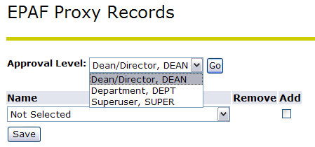

- From the Name drop down menu, select the individual to designate as the Proxy Approver.
- Click Add next to the individual’s name, then click Save.
- To remove a Proxy Approver, click Remove next to the individual’s name and click Save.
- A Proxy must have security access at the designated approval level.

V - Act as a Proxy Approver

To act as a proxy, select Act as a Proxy link.

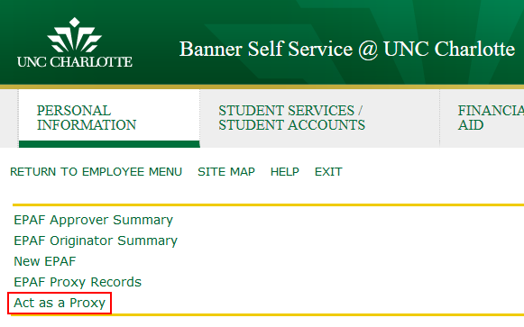
Select the individual you wish to Proxy For with the drop down menu.

Submitted From Date and Submitted To Date: Leave blank if you want to see all EPAFs that require this individual’s approval or input submission date parameters.

Click Go.

A Proxy will have access to approve, acknowledge, or return EPAFs at the approval level for which they have been designated by the EPAF Approver.

VI - Set up a Default Routing Queue

A Default Routing Queue allows the user to customize the routing queue for every Approval Category, or type of EPAF, that they create. This should be done before the first EPAF is created.

Select Default Routing Queue

Select the Approval Category from the dropdown list. Press Go.

Use the magnifying glass search function to fill in the open data fields for each required approval level.

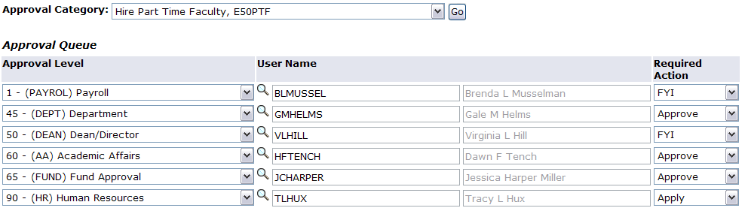

Press when complete.

