**Review open Purchase Order Encumbrances in Banner**

**FGIOENC** – Organizational Encumbrance List

Query on this Banner form by Organization number to return a list of open PO Encumbrances.  Click on a specific encumbrance and use F3 to drill down to form FGIENCD for detail information.  A few examples of POs that should be closed:

* The shipping was less than expected so there is a small balance left on the PO.
* The invoice was less than expected (perhaps because of a discount) and there is a small balance left on the PO.

To close a PO, email your Purchasing Agent for assistance, including the PO#, the vendor name and the remaining balance.  Click on the following link to see a list of Purchasing Agents by Organization:  <http://finance.uncc.edu/sites/finance.uncc.edu/files/media/PurchasingAgentsAssignmentJune2012.pdf>

You may find that an older PO hasn’t been invoiced yet.  If you have a copy of the invoice in your files, Accounts Payable may have never received a copy of the invoice.  Scan and email the invoice to [acctpay@uncc.edu](mailto:acctpay@uncc.edu) or put the invoice in interoffice mail addressed to Accounts Payable.

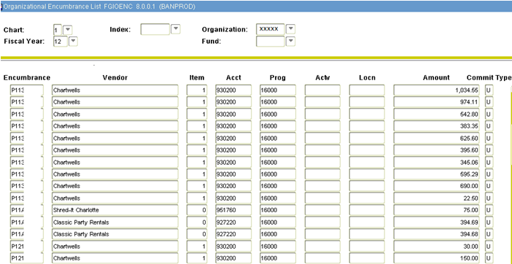

When reviewing outstanding POs on FGIOENC, you may see encumbrances that start with PR.  These are Payroll encumbrances and will clear out at Year End.  You do not need to worry about them at this time.

Most POs at this point were created in 49er Mart and were invoiced and received in 49er Mart, but you may run across an older PO that was invoiced and received in Banner instead.  Invoicing and receiving in 49er Mart started on 1/18/2011.  To review a PO in Banner, use the form FOIDOCH.

Once the list of open POs that need research is established from FGIOENC, the POs can be researched in 49er Mart to see if receiving was completed or to see if the PO has been invoiced yet.